Renegade Leadership Flipped Book Study

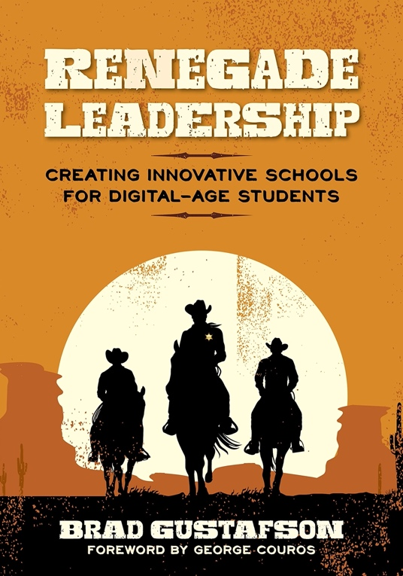
- INTRODUCTION. Renegades Needed
- CHAPTER 1. Renegade Leadership Defined
- CHAPTER 2. Relationships and Culture
- CHAPTER 3. The Renegade CODE
- CHAPTER 4. Collaboration for Digital-Age Students
- CHAPTER 5. Ownership: Empowering Digital-Age Students
- CHAPTER 6. Digital-Connectivity for Digital-Age Students
- CHAPTER 7. Experiential Learning is Deeper Learning
- CHAPTER 8. Instructional Leadership for the Digital Age
- CHAPTER 9. Personalized PD to Empower Educators
- CHAPTER 10. Activate Your Renegade Leadership
- RENEGADE LEADERSHIP SCALE.
- #RENLEAD PLN BUILDER.
- REVIEWS.

Introduction. Renegades Needed

Flipped Book Study: Watch the Introduction Video before reading to enhance your learning.

Note from the Author: A quick Google search of "School Leadership Books" will yield nearly 253,000,000 results. So why add another book and website to the list? My "why" is because all students deserve innovative schools that reflect the possibilities of the digital age.

Audio Outtakes: Supercharge your book study with these shareable chapter-by-chapter audio clips with colorful commentary. Connect with Brad to schedule him to join your book study or university class "live" on Skype, GHO, or Voxer. Audio Outtakes

Water Cooler Questions:

- Why are you reading Renegade Leadership and connecting in this online space?
- What is your 'why'?

Additional Listening/Viewing:

- Know Your Why: This four minute video by Michael Jr. is one of the most powerful messages I have seen. Listen to his message and then share your 'why' using #RenLead on Twitter.

CHAPTER 1. Renegade Leadership Defined

Flipped Book Study: Watch the Chapter 1 Video before reading to enhance your learning.

Audio Outtakes: Supercharge your book study with these shareable chapter-by-chapter audio clips with colorful commentary. Connect with Brad to schedule him to join your book study or university class "live" on Skype, GHO, or Voxer. Audio Outtakes

Water Cooler Questions:

- Why is pedagogical precision so important?
- What practices do we need to pause or say "no" to in order to create space for innovative best practices?
- How might the Renegade Leadership scale help inform our work?

Additional Listening/Viewing:

- #30SecondTake Podcast: Two school leaders give their quick 'takes' on a Water Cooler Question from chapter one.
- Crowd Accelerated Innovation: Chris Anderson's TED Talk discusses the conditions that cultivate innovation.
- UnearthED on the BAM Radio Network: A discussion of what "permission to innovate" sounds like to a teacher.
- The Backwards Brain Bicycle: Creating innovative schools requires that we understand what is involved in unlearning.

Additional Blog Posts:

- Compliance/Control vs. Creativity/Innovation (2015) by Michael Niehoff. A commentary on the collision of two worlds, and the leadership required to link best-practice and innovation.
- We Have to Stop Pretending (2015) by Pam Gilders. This blog post relates to the Water Cooler Question, "What do we need to pause or say 'no' to in education?

Additional Books:

- Kids Deserve It! (2016) by Todd Nesloney and Adam Welcome
- The Innovator's Mindset (2015) by George Couros

Double-Down Challenge:

Personalize your learning by selecting from mini-challenges at the conclusion of each chapter. Most chapters offer at least two different options to personalize your learning.

​
- Challenge 1.1: Understanding Your Leadership Lenses

​

Take the Renegade Leadership Scale found in Chapter 1. Use the scale as a self-diagnostic tool and reference it as you read subsequent chapters. Share a reflection or something you noticed when completing the scale on the companion website forum below.

CHAPTER 2. Relationships and Culture

Flipped Book Study: Watch the Chapter 2 Video before reading to enhance your learning.

Audio Outtakes: Supercharge your book study with these shareable chapter-by-chapter audio clips with colorful commentary. Connect with Brad to schedule him to join your book study or university class "live" on Skype, GHO, or Voxer. Audio Outtakes

Water Cooler Questions:

- What are the leadership behaviors we model that show relationships matter?
- How does a school's culture lend itself to academic improvement and innovation?
- How might we cultivate connectedness in digital-age schools?

Additional Listening/Viewing:

- The Unexpected Benefit of Celebrating Failure: What if we sought failure in schools instead of trying to avoid it at all costs? Renegade Leadership is loaded with stories of epic failure and lessons learned.
- Where Good Ideas Come From: This whiteboard video discusses the space where creativity and innovation thrive...relationships and culture can facilitate the collision and iteration of ideas that Johnson describes.
- Principal Trading Card #1 (powered by augmented reality): This brief demo shows how an old-fashioned trading card triggers supplemental video content when using an augmented reality app. The concept was expanded upon in Chapter 2 of Renegade Leadership.
- Principal Trading Card #2 (powered by augmented reality): This brief demo shows how a basketball trading card triggers supplemental video content when using an augmented reality app. The concept was expanded upon in Chapter 2 of Renegade Leadership.

Additional Blog Posts/Articles:

- Flip Your School Culture (2015) by Michael Niehoff. Before we try to transform how technology is used, or change our schools' strategic goals, we need to consider the role of culture.

Additional Books:

- Transforming School Culture (2009) by Anthony Muhammad
- The Missing Voices in EdTech (2015) by Rafranz Davis

CHAPTER 2. Relationships and Culture (continued)

Double-Down Challenge:

Personalize your learning by selecting from mini-challenges at the conclusion of each chapter. Most chapters offer at least two different options to personalize your learning.

​
- Challenge 2.1: Connectedness Makes a Difference

​

Identify the day-to-day interactions of staff that exemplify your vision for your school's culture. Take time to connect and personally thank the difference-makers doing this work.

​
- Challenge 2.2: Owning Our Impact and Influence

​

Lucy Stone disregarded the impossible and impacted the culture and trajectory of an entire country. What have you been avoiding that needs to be confronted? What conversations are your students counting on you to have? Start the process.

CHAPTER 3. The Renegade Code

Flipped Book Study: Watch the Chapter 3 Video before reading to enhance your learning.

Audio Outtakes: Supercharge your book study with these shareable chapter-by-chapter audio clips with colorful commentary. Connect with Brad to schedule him to join your book study or university class "live" on Skype, GHO, or Voxer. Audio Outtakes

Water Cooler Questions:

- What is a connected pedagogy?
- Which tenets from the Renegade CODE are most important? Why?
- How might pedagogy help us apply innovation to best practice?

Additional Listening/Viewing:

- What is Pedagogy? This two minute video provides an academic definition for the term, pedagogy. What parts of the video resonated, and what do you think has changed since 2011?

​

Additional Blog Posts:

- Are We There Yet? (2016) by Dr. Brad Gustafson. A short reflection on pedagogy and the purpose of education.
- Eager to Be Wrong (2016) by Farnam Street. Why do we continue to teach and lead using a familiar pedagogy? This blog post reveals the role (and strain) of cognitive dissonance in perpetuating the status quo.

Additional Books:

- Passionate Learners (2015) by Pernille Ripp
- Freedom to Fail (2015) by Andrew K. Miller

Double-Down Challenge:

Personalize your learning by selecting from mini-challenges at the conclusion of each chapter. Most chapters offer at least two different options to personalize your learning.

​
- Challenge 3.1: Pedagogical App-rehension

​

Approach conversations about technology, communication, and apps/tools with a new level of discernment. The next time you share a new app, identify what tenet(s) of the Renegade CODE the app supports. Share the pedagogical reasons along with your endorsement of the app.

​
- Challenge 3.2: Innovate Like an Artist

​

Jackson Pollock was an innovative artist whose skill was uncanny. Introduce an innovative element to your staff meetings, but do it with purpose and precision. Which tenets of the Renegade CODE will support the innovation you will introduce to meetings?

CHAPTER 4. Collaboration for Digital-Age Students

Flipped Book Study: Watch the Chapter 4 Video before reading to enhance your learning.

Audio Outtakes: Supercharge your book study with these shareable chapter-by-chapter audio clips with colorful commentary. Connect with Brad to schedule him to join your book study or university class "live" on Skype, GHO, or Voxer. Audio Outtakes

Water Cooler Questions:

- How might we amplify the voices of our most introverted students and staff?
- What is the relationship between collaboration and moral courage?
- Can collaboration and connectedness be done incorrectly?

Additional Listening/Viewing:

- How Collaborative Leadership Delivers Sustainable Innovation: Learn how the Harvard Business School leverages collaborative leadership to incubate innovative ideas.
- Collaboration & Teamwork: Hear how Steve Jobs viewed collaboration, committees, and the leadership hierarchy at Apple.

Additional Blog Posts:

- Connected Learning (2014) by Dr. Brad Gustafson. Learn how educators across the country are connecting their classrooms to more collaborative learning experiences.

Additional Books:
- Amplify (2015) by Katie Muhtaris and Kristin Ziemke
- 5 Skills for the Global Learner (2015) by Mark Barnes

Double-Down Challenge:

Personalize your learning by selecting from mini-challenges at the conclusion of each chapter. Most chapters offer at least two different options to personalize your learning.

​
- Challenge 4.1: Cross-Site Collaboration

​

Model collaboration for your staff by connecting with another school. Create a shared product (podcast, blog post, article) that showcases the power of collaboration. Share your product on the #RenLead hashtag.

​
- Challenge 4.2: Moral Courage to Do the Right Work

​

Just like Rafranz Davis and the Lufkin leadership team, you could reflect on your current reality together with district staff. Dig deeper into how culturally sensitive your system is and your own next steps. Start a book study. Identify your current reality and collaborate on a path forward.

CHAPTER 5. Ownership: Empowering Digital Students

Flipped Book Study: Watch the Chapter 5 Video before reading to enhance your learning.

Audio Outtakes: Supercharge your book study with these shareable chapter-by-chapter audio clips with colorful commentary. Connect with Brad to schedule him to join your book study or university class "live" on Skype, GHO, or Voxer. Audio Outtakes

Water Cooler Questions:

- What are some of the best things that could result from giving students more ownership of their learning?
- How integral is student voice to the daily rhythms of our school?
- How can we provide child-centered leadership that changes the hierarchy of learning in schools?

Additional Listening/Viewing:

- Donovan Livingston's Commencement Speech: This Harvard commencement speech is one of the most thought-provoking I have heard. An amplified voice is a powerful catalyst to transformation.
- Power to the Pupil: This TEDx Talk takes us on Jen's journey to empower her students. Creativity and innovation are not a luxury reserved for select zip codes and schools!

Additional Blog Posts:

- A Walk to Remember (2016) by Joan Valentine. It's all about perspective! Learn a powerful strategy to help understand students better.
- Before You Hang Up That Public Behavior Chart (2014) by Pernille Ripp. I dare you to read this blog post and not change your thinking about classroom behavior charts.

Additional Books:

- Worlds of Making (2015) by Laura Fleming
- Uncommon Learning (2015) by Eric Sheninger
- Learning by Choice (2015) by A.J. Juliani

CHAPTER 5. Ownership: Empowering Digital Students (continued)

Double-Down Challenge:

Personalize your learning by selecting from mini-challenges at the conclusion of each chapter. Most chapters offer at least two different options to personalize your learning.

​
- Challenge 5.1: Student-Centered Conversations

​

Jennie Magiera works with hundreds of educators who possess different skills and readiness levels. She differentiates the conversations based upon each person's needs. Ask five different teachers about school-wide student ownership. Try to identify new ways to create a more child-centric school.

​
- Challenge 5.2: A Risk You Won't Regret

​

Patsy Sherman encouraged others to look at the world through inventor's eyes. Take a look at your leadership through the eyes of student agency. What do you need to give kids more control over? Start by asking students, and then take a risk by listening to them!

CHAPTER 6. Digital-Connectivity for Digital-Age Students

Flipped Book Study: Watch the Chapter 6 Video before reading to enhance your learning.

Audio Outtakes: Supercharge your book study with these shareable chapter-by-chapter audio clips with colorful commentary. Connect with Brad to schedule him to join your book study or university class "live" on Skype, GHO, or Voxer. Audio Outtakes

Water Cooler Questions:

- What are some misconceptions about digital-connectivity?
- What is the difference between meaningful technology integration and diminished learning?
- How might digital-connectivity transform traditional leadership practices?

Additional Listening/Viewing:

- The LAUNCH Cycle: The LAUNCH Cycle can be used to support students' design thinking when building with tape and cardboard or digital tools.
- An Introduction to Technology Integration: This five minute video details how technology can transform learning. Hear from Adam Bellow and others as they share the power of connection, creation, and more!

Additional Blog Posts:

- 3 Reasons Your Students Should be Blogging (2015) by Jeff Herb. This post provides a succinct rationale why we should all provide kids an authentic audience for their work.
- A Narrow View? (2015) by George Couros. Learn how one school eradicated digital-connectivity (and all screens). Share your reflections in the #RenLead forum below.

Additional Books:

- 140 Twitter Tips for Educators (2016) by Brad Currie, Billy Krakower, and Scott Rocco
- Launch (2016) by John Spencer and A.J. Juliani

CHAPTER 6. Digital-Connectivity for Digital-Age Students (continued)

Double-Down Challenge:

Personalize your learning by selecting from mini-challenges at the conclusion of each chapter. Most chapters offer at least two different options to personalize your learning.

​
- Challenge 6.1: Invite Others in Through Transparency

​

Reflect upon how a hashtag or other transparent sharing may help bring people together. If you already have a district or school hashtag, identify an event or project that might be enhanced through more open sharing.

​
- Challenge 6.2: Thinking Outside the System

​

Capacity building can sometimes occur when we step back from the familiar...or look at seemingly unrelated components as part of a larger system. (The Lego Company created a system of plastic bricks that work together.) How can you improve a learning experience for students or staff by connecting with somebody outside the educational system?

CHAPTER 7. Experiential Learning is Deeper Learning

Flipped Book Study: Watch the Chapter 7 Video before reading to enhance your learning.

Audio Outtakes: Supercharge your book study with these shareable chapter-by-chapter audio clips with colorful commentary. Connect with Brad to schedule him to join your book study or university class "live" on Skype, GHO, or Voxer. Audio Outtakes

Water Cooler Questions:

- What makes a learning experience authentic and memorable?
- Why is connectedness an important part of 'future ready' learning?
- How might we ensure state standards and accountability expectations are exceeded while still championing the needs of the whole child?

Additional Listening/Viewing:

- Project Based Learning Explained: Learn how and why the pathway to relevant, lasting learning requires experiential learning.

Additional Blog Posts:

- If Ferris Bueller was at Our School (2016) by Adam Welcome & Jon Harper. Loaded with examples of experiential learning, this post connects a classic movie to the schools our students deserve!

Additional Books:

- Teach Like a Pirate (2012) by Dave Burgess
- Learn Like a Pirate. (2015) by Paul Solarz

Double-Down Challenge:

Personalize your learning by selecting from mini-challenges at the conclusion of each chapter. Most chapters offer at least two different options to personalize your learning.

​
- Challenge 7.1: Experiencing Connectivity

​

Best practice has been somewhat confined by the walls of a classroom or school. Create a connected learning experience using a lesson or leadership practice that is traditionally been limited to the scope of your school. Be sure that the learning drives the experience.

​
- Challenge 7.2: Student Centered Reform

​

School leaders often operate in their comfort zone or wheelhouse. While strengths-based leadership has its place, Noah Webster learned 20 different languages to reform spelling. Identify something new you need to learn to be more student centered.

CHAPTER 8. Instructional Leadership for the Digital Age

Flipped Book Study: Watch the Chapter 8 Video before reading to enhance your learning.

Audio Outtakes: Supercharge your book study with these shareable chapter-by-chapter audio clips with colorful commentary. Connect with Brad to schedule him to join your book study or university class "live" on Skype, GHO, or Voxer. Audio Outtakes

Water Cooler Questions:

- What is our vision for effective instruction? Is it a shared vision?
- How does pedagogical precision apply to instructional leadership?
- How might we apply innovation to help all students learn?

Additional Listening/Viewing:

- Instructional Leadership: A riveting reflection of instructional leadership to drive student success through the 20% principle.

Additional Blog Posts:

- You Can't Support Teachers If You Aren't In Their Classrooms! (2016) by Todd Schmidt. You can't support teachers if you aren't in their classrooms! This blog post packs a punch...and some practical ideas to enhance your instructional leadership.
- Classroom Eye Candy: A Flexible-Seating Paradise (2015) by Jennifer Gonzalez. The ideas and pictures in this post are underpinned by a 21st century pedagogy. Classroom design is a critical component of instruction.

Additional Books:

- Redesigning Learning Spaces (2016) by Robert Dillon, Ben Gilpin, and A.J. Juliani
- Visible Learning (2008) by John Hattie
- Invent to Learn (2013) by Gary Stager and Sylvia Libow Martinez
- The Space (2016) by Rebecca Louise Hare and Dr. Robert Dillon

CHAPTER 8. Instructional Leadership for the Digital Age (continued)

Double-Down Challenge:

Personalize your learning by selecting from mini-challenges at the conclusion of each chapter. Most chapters offer at least two different options to personalize your learning.

​
- Challenge 8.1: Common Practices

​

To what degree is a common frame work for effective teaching in place at your school? What practices do you believe are core elements of instruction? Create a list and converse with staff to verify that everyone is on the same page.

​
- Challenge 8.2: Transform a Space with Precision and Innovation

​

Apply innovation and pedagogical precision to transform a space in your school. How might you involve others in the process?

​
- Challenge 8.3: Leadership for ALL Students

​

Prepare to participate in a courageous conversation pertaining to diversity. What questions will you ask when the opportunity arises? Increase staff capacity and empathy through literature. You might start a book study or introduce picture books like Sarabeth deNeui did.

CHAPTER 9. Personalized PD to Empower Educators

Flipped Book Study: Watch the Chapter 9 Video before reading to enhance your learning.

Audio Outtakes: Supercharge your book study with these shareable chapter-by-chapter audio clips with colorful commentary. Connect with Brad to schedule him to join your book study or university class "live" on Skype, GHO, or Voxer. Audio Outtakes

Water Cooler Questions:

- Is there a difference between professional development and professional learning?
- What are the characteristics of PD that actually increase the capacity of participants?
- How might PD look if educators were further empowered to own their learning?

Additional Listening/Viewing:

- UnearthED on the BAM Radio Network: A discussion of what professional learning could (and should) be for educators.
- What is a Badge? A brief (3 minute) overview of digital badges and how they can support anytime, anywhere learning.

Additional Blog Posts:

- Cheesecake Factory Professional Development (2016) by Ross Cooper. Beware of providing too many PD options in your pursuit to personalize professional learning. Focus is key!
- Empowered Learning (2014) by Dr. Brad Gustafson. The factory model of PD leaves a lot to be desired. Planning PD that actually empowers educators is possible.

Additional Books:

- Personalized PD (2015) by Jason Bretzmann, Dr. Brad Gustafson, Kenny Bosch, Brad Currie, Kristin Daniels, Laura Conley & Ben Wilkoff
- Leading Professional Learning (2015) by Thomas C. Murray and Jeffrey Zoul

Double-Down Challenge:

Personalize your learning by selecting from mini-challenges at the conclusion of each chapter. Most chapters offer at least two different options to personalize your learning.

​
- Challenge 9.1: Let Students Lead to Build Capacity

​

Identify a skill-set or area of passion that your students possess. Invite them to share before a PD session or empower students to actually lead the learning.

​
- Challenge 9.2: Empowered Learning via Passion-Based PD

​

Dave Grohl followed his passion with little formal training. Plan a staff learning experience that provides your team more autonomy. Try accounting for different interests, readiness levels, and learning preferences. Whether you decide to flip a meeting or plan an un-conference...strive to create passion-based PD.

CHAPTER 10. Activate Your Renegade Leadership

Flipped Book Study: Watch the Chapter 10 Video before reading to enhance your learning.

Audio Outtakes: Supercharge your book study with these shareable chapter-by-chapter audio clips with colorful commentary. Connect with Brad to schedule him to join your book study or university class "live" on Skype, GHO, or Voxer. Audio Outtakes

Water Cooler Questions:

- Which of the subtle shifts can we be more purposeful in changing?
- How might we enhance hiring results by subtly changing the questions we ask?
- What traditional best practice could we apply innovation to in order to achieve amplified learning?

Additional Listening/Viewing:

- Schools that Work for Kids: A compelling look at what "real learning" looks like to kids, and why schools need to change to be more responsive.

Additional Blog Posts:

- My Incredible Educator Journey (2014) by Jay Posick. A powerful reminder of the importance of mentoring.
- The Rush (2015) by Dr. Brad Gustafson. Before we rush to implement change we must take a critical look at pedagogy.

Additional Books:

- Hacking Leadership (2016) by Joe Sanfelippo and Tony Sinanis
- What Connected Educators Do Differently (2015) by Todd Whitaker, Jeffrey Zoul, and Jimmy Casas

CHAPTER 10. Activate Your Renegade Leadership (continued)

Double-Down Challenge:

Personalize your learning by selecting from mini-challenges at the conclusion of each chapter. Most chapters offer at least two different options to personalize your learning.

​
- Challenge 10.1: Mentor and Amplify

​

Meet with a student teacher or group of university students. Take time to talk pedagogy and technology, and then provide them the opportunity to take initiative on a larger-scale project that pushes their thinking.

​
- Challenge 10.2: Practice Fearless Learning

​

As yourself, "What are my people counting on me to learn?" Connect with constituents and let them tell you! Attend an EdCamp or participate in Twitter-based PD. Finally, revisit the Renegade Leadership Scale (from chapter 1) to reflect on your next steps. Share how you practiced fearless learning via the #RenLead hashtag on Twitter.

​
- Challenge 10.3: All-Star Caliber Support

​

Be more intentional about the induction process. Start by creating a video or press release, and continue by making personal phone calls to the families of new staff. Add your own meaningful supports to the process and share out your efforts in a blog post or via the #RenLead hashtag on Twitter

​
- Challenge 10.4: Talk About It

​

Identify the "10 Percent" type conversations you need to have this school year. The bulk of these conversations will likely be about building upon best practice through pedagogy, or applying innovation. However, one or two will probably involve courageous conversations that address behaviors or habits that have formed over time. Reach out to a trusted colleague and commit to following up on these conversations.

​
- Challenge 10.5: Learning Questions

​

Transform one (or more) of the interview questions you are currently asking from a "leading" question to a "learning" question. Share the before/after in a blog post or Tweet using the #RenLead hashtag.

​
- Challenge 10.6: Focus on Pedagogy

​

Write down the tenets from the Renegade CODE in a prominent place in your office or classroom. (You could reproduce Figure 3.1 if that is easier.) Tweet a picture of the CODE near your workstation to the #RenLead hashtag on Twitter.

Renegade Leadership Scale

The Renegade Leadership Scale pushes us to look at different leadership traits through different lenses. Complete directions on using the scale are found in the book, Renegade Leadership.

​

To begin using the scale, circle a "1" if you are unable to provide much evidence of a particular trait relative to the lens you are viewing it through. If you can cite numerous examples be sure to circle a "4" or "5" in that particular column.

​

After completing the scale, total up the numbers in each column and begin crafting your action plan based upon your unique leadership profile.

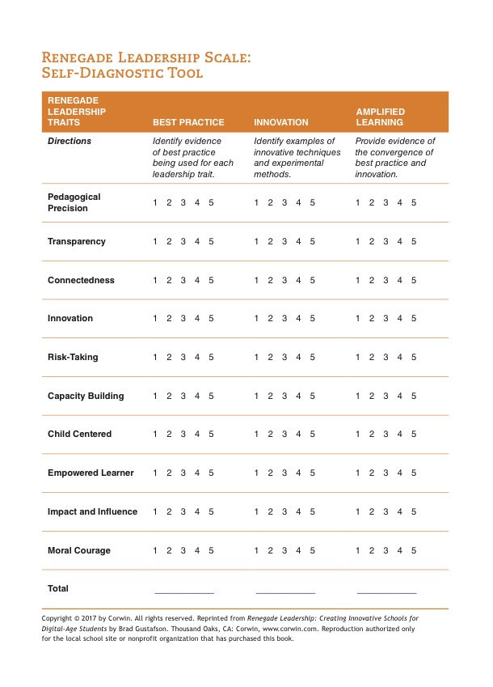

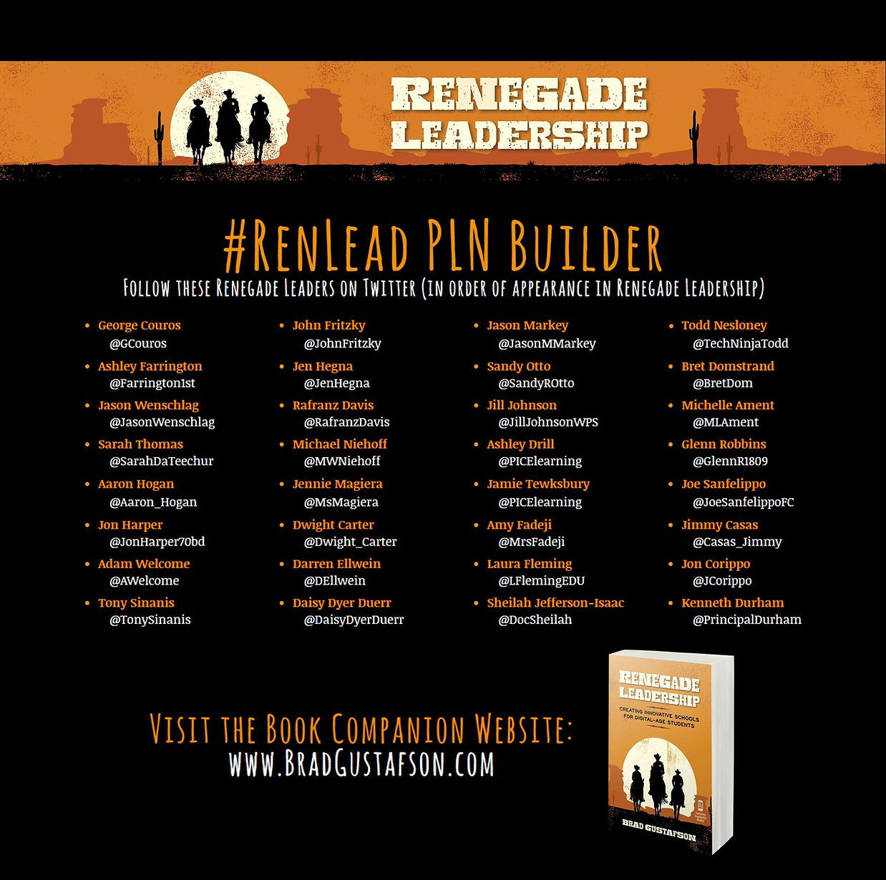

Reviews

"It is important that we start to think differently about leadership. Renegade Leadership is so crucial to the work that we do in education. If we do change right, schools can be a place where we are not just trying to catch up to the innovation around us, but we can be leading it for the entire world. Think about it . . . why can’t schools be the place that other organizations look to for innovation?"

​
- George Couros. Innovative teaching, learning, and leadership consultant and Author of The Innovator’s Mindset

"In Renegade Leadership, Dr. Brad Gustafson provides invigorating, concrete examples of strategic thinking and skills for educational leaders to fill the vacuum that exists in many educational settings. Gustafson asserts that leadership and change in education are irrevocably intertwined. Renegade Leadership is there for everyone to partake - you just have to decide to commit."

​
- Jon Corippo. Director of Academic Innovation, CUE

"Renegade Leadership demonstrates what student-centered schools look like in the digital age. When we get relationships and pedagogy right, we can transform the very nature of learning. The vulnerability of Brad Gustafson's open sharing combined with his practical advice make this an incredible classroom resource. This is a book our students desperately need us all to read."

​
- Erin Klein. Scholastic Top Teacher and Michigan Teacher of the Year

"Renegade Leadership is a gold mine of inspiring stories, practical ideas and authentic examples of school transformation. It's a book that all educators should read, as we can all be leaders in improving schools no matter what our title or position."

​
- Jennie Magiera. Author of Courageous Edventures

"WOW! Renegade Leadership is loaded with great ideas that any educator could adapt in their own space. I particularly loved the concrete examples of innovation happening in Brad’s school; from the drone challenges, and community service group, to the live-streaming of events so students with sensory issues can join from their classrooms. This book offers a glimpse into the future of best practice. The pedagogy is presented by a practitioner who understands the importance of purpose and higher-level learning. I am so inspired by this text and cannot wait to try some of the ideas in our own district. This is a MUST READ for all educators and especially educational leaders!"

​
- Tony Sinanis. Elementary School Principal and Author

"Dr. Brad Gustafson’s compendium of workable ideas will provide school leaders with guidance and the best PD they will have had for a long time. Readers will be moved by his contagious enthusiasm as he shares the great ideas that worked in his school."

​
- Neil MacNeill. Head Master, Ellenbrook Independent Private School

"A great combination of discussion on pedagogy, professional learning, digital age instructional leadership, culture, and relationships – this book provides so many opportunities for reflection as well as turnkey strategies that will impact the cultures of our schools. The power of the instructional leader is captured in inspiring ways; I found myself wanting to put this in the hands of all my principals for immediate use in their buildings."

​
- Rich Hall. Director of Elementary Education, Henrico County Public Schools

"The concept of Renegade Leadership is an idea whose time has come in an age of educational volatility and insecurity."

​
- John Robinson. High School Principal, Newton-Conover City Schools

"Engaging, sincere. Creative ideas are presented within every chapter as well as rich possibilities for innovating student and staff learning. This text contains content with the potency of a time machine many school leaders dream of having: take me to relevant, simple yet profound ideas to bring instruction and curriculum at my school into the new realm of learning to prepare students for their world."

​
- Virginia E. Kelsen. Executive Director, College and Careers, Chaffey Joint Union High School District

"Be prepared to be inspired! I’m a huge fan of Brad Gustafson because of the energy and passion he puts into his leadership. In Renegade Leadership: Creative Innovative Schools for a Digital Age, readers will feel that energy and passion in each and every page. Gustafson offers a step-by-step how to guide for school leaders. Read, learn and innovate!"

​
- Peter DeWitt. Author and Consultant

"Renegade Leadership has the most comprehensive companion website I've seen. It offers flipped videos, community forum components, and diverse opportunities to extend educators’ learning as far as they choose. The book and website together provide extensive and intensive personalized professional development that readers will want to dive into over and over again."

​
- Jason Bretzmann. Teacher and Author of Flipping 2.0 and Personalized PD
